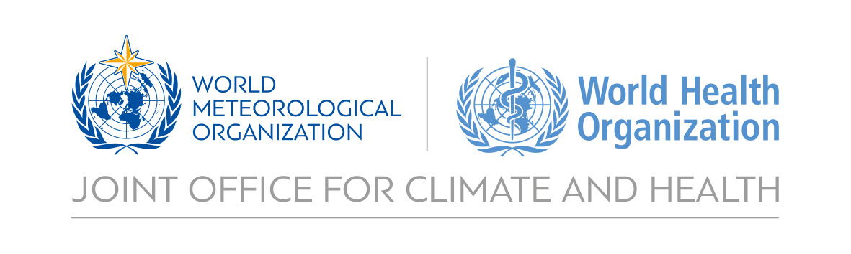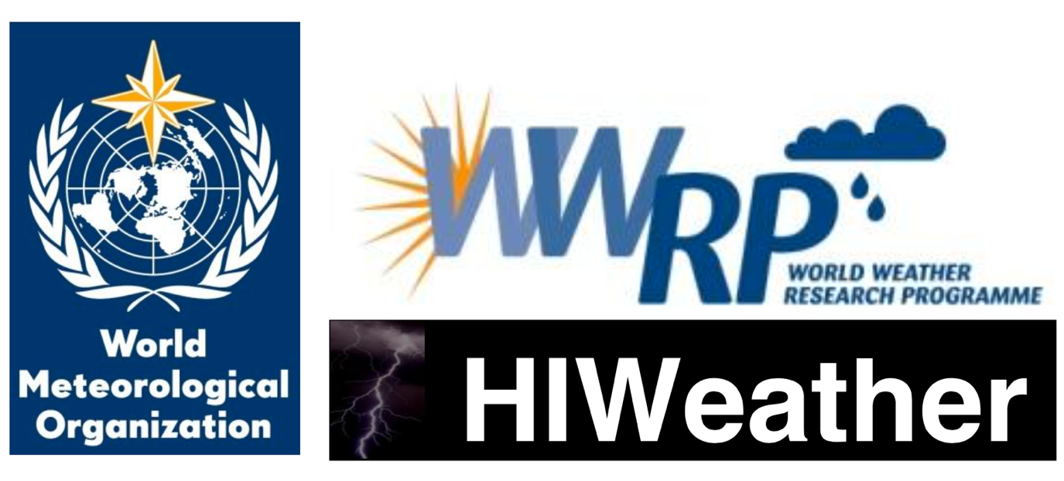

**White Paper on Health Linkages to HIWeather**

**Draft outline**

**Version: 22nd September 2017**

Authors: Robert Parks, etc

Table of contents

Figures and tables 3

1. Introduction 4

2. Structure of white paper 5

3. Decision-making processes in disaster action plans 6

1. Decision-making structure 6

2. Iterative management of decision-making structure 6

3. Identity of decision makers 8

4. Timeline of key decisions and processes 8

4. Key metrics to track health impacts of and vulnerability to disasters 9

Outlines of HIWeather focus areas 10

1. Urban Flood 10

Overview 10

Health impacts 10

How forecasting fits into urban Flood Action Plans (FAPs) 11

Key processes made in preparedness and action plans 13

Key gaps in real-time monitoring, forecasting and alert capabilities 14

Key opportunities to develop or improve health relevant deliverables 14

Potential pilot projects with improved forecasting 15

2. Wildfire 17

Overview 17

Health impacts 17

Key processes made in preparedness and action plans 18

Key gaps in real-time monitoring, forecasting and alert capabilities 18

Key opportunities to develop or improve health relevant deliverables 18

Potential projects with improved forecasting 18

3. Localised Extreme Wind 19

Overview 19

Health impacts 19

Key processes made in preparedness and action plans 20

Key gaps in real-time monitoring, forecasting and alert capabilities 20

Key opportunities to develop or improve health relevant deliverables 20

Potential projects with improved forecasting 21

4. Disruptive Winter Weather 22

Overview 22

Health impacts 22

Key processes made in preparedness and action plans 23

Key gaps in real-time monitoring, forecasting and alert capabilities 23

Key opportunities to develop or improve health relevant deliverables 23

Potential projects with improved forecasting 23

5. Urban Heat Waves and Air Pollution 24

Overview 24

Health impacts 24

How forecasting informs heat wave and air pollution health action plans 25

Key processes made in preparedness and action plans 25

Key gaps in real-time monitoring, forecasting and alert capabilities 25

Key opportunities to develop or improve health relevant deliverables 26

Potential projects with improved forecasting 26

References 27

# Figures and tables

Figure 1. Potential flow of information between a lead body and other actors involved in heat action plans. 4

Figure 2. Communications plan for Ahmedabad Heat Action Plan 5

Figure 3. Schematic representation of time frames set out by WHO for implementing the core elements of a heat action plan.3 6

Table 1. Key focal areas of HIWeather and the outline in this report for each. 3

Table 2. Indicators from monitoring processes relevant to disasters. 7

# Introduction

Disasters globally since 1990 have caused the deaths of over 1.6 million people.1 High Impact Weather (HIWeather), a research activity within the World Weather Research Programme (WWRP), **aims to improve extreme weather event forecasting, both in spatial resolution and predictive lead time, from two mins to two weeks**. A significant beneficiary of HIWeather products could be decision makers in disaster early warning systems and emergency health care provision, who would be able to use improved forecasting techniques to better prepare for approaching extreme weather. The Sendai Framework for Disaster Reduction has the explicitly-stated target of ‘the substantial reduction of disaster risk and losses in lives, livelihoods and health’, which behoves HIWeather to also work towards this goal.2

However, a significant knowledge gap exists in the HIWeather operation plan in terms of **where**, **when**, and **how** significant health care decisions are made, and could be improved through the use of enhanced weather forecasting. Further, missing is a detailed awareness of how much lead time is needed for health care decisions. If a significant goal of HIWeather is to improve health outcomes by successful utilisation of its products, the direction of improved HIWeather products must be steered by the awareness and knowledge of the nature of disaster-related health care decisions by the end user in the ‘last-mile’.

This white paper aims to give an exposition on key health risks being managed for each of the 5 Hi-Weather focus hazard areas, process by which health care decision makers build a timeline of required action. The report will be structured around each of the 5 areas of focus of HIWeather.

**The logic of this approach is to begin with the desired health outcome improvements, and work systematically through the processes to identify where HIWeather products could be applied or tailored to assist the health sector.**

In this way, the selection and development of HIWeather products will be informed by how to prevent and reduce health impacts at the heart its direction.

# About this report

The report begins with an overview of **key decision-making processes and timelines**, as well as **key metrics as trackers for disaster-related health outcomes**. Five sections, organized by the Hi-Weather Focus areas then describe the associated the health impact to each type of hazard; outlines how improved forecasting could inform the management of these risks; provides timelines of key decisions; describes gaps in forecasting capabilities; key deliverables which could be of value to health professionals, and then identifies pilot projects which could be developed for further research and development of these products. (Table 1):

Table 1. Key focal areas of HIWeather and the outline in white paper for each area.

|  |  |
| --- | --- |
| HIWeather Focus Areas | Areas of Health Linkages to be outlined for each Focus Area |
| 1. urban flood 2. wildfire 3. localised extreme wind 4. disruptive winter weather 5. urban heat waves and air pollution | * **1.1 Health impacts.** Summarizes key health impacts associated with each focus weather hazard area, as well as key vulnerabilities * **1.2 How weather forecasting informs action plans.** The current ways in which forecasting is beneficial to decision makers * **1.3Timeline of key decisions and processes.** Create timeline of decisions which need to be made by key decision makers. * **1.4Key gaps in weather forecasting capabilities.** Identify key gaps in capabilities of forecasting (both in time and space) which can be improved upon to help decision makers make decisions.   **1.5 Key deliverables.** To improve capabilities of decision-makers to avert disaster-related deaths.  **1.6 Potential projects with improved forecasting.** Potential projects serving as focused health outcome-based research for HIWeather. |

# Decision-making processes in disaster action plans

## Decision-making structure

When disasters are forecast, it is important that a consolidated well-functioning decision-making process is in place to enable a smooth roll-out of emergency measures. At key points in the disaster-forecasting timeline, there are essential communication pathways between decision makers and practitioners. The Sendai Framework for Disaster Risk Reduction 2015-2030 makes strengthening disaster risk governance to manage disaster risk one of its four priorities for action.2

Figure 1 demonstrates the potential flow of information between decision-makers during consideration of activating a Heat Health Action Plan (HHAP)3. Figure 2 showcases an example, from the Ahmedabad Heat Action Plan, with more detail on the methods of communication between decision makers and practitioners. Figure 3 shows an example from the Thailand HHAP.4

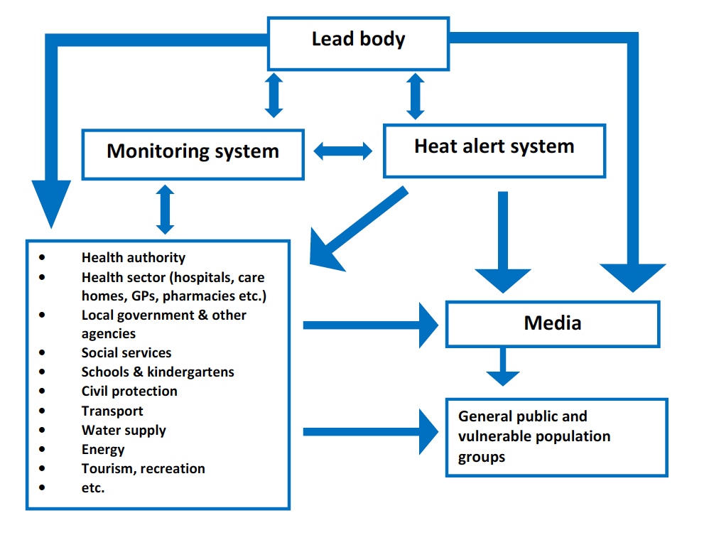

Figure 1. Potential flow of information between a lead body and other actors involved in heat action plans.

## Iterative management of decision-making structure

While it is important to set up a clear disaster management decision-making structure, it is crucial that these systems of management are reassessed iteratively over time, especially for when the structure is in place with a calendar year, if, for example with a heat wave action plan, the occurrence and management of disaster is only required at certain times of the year.5

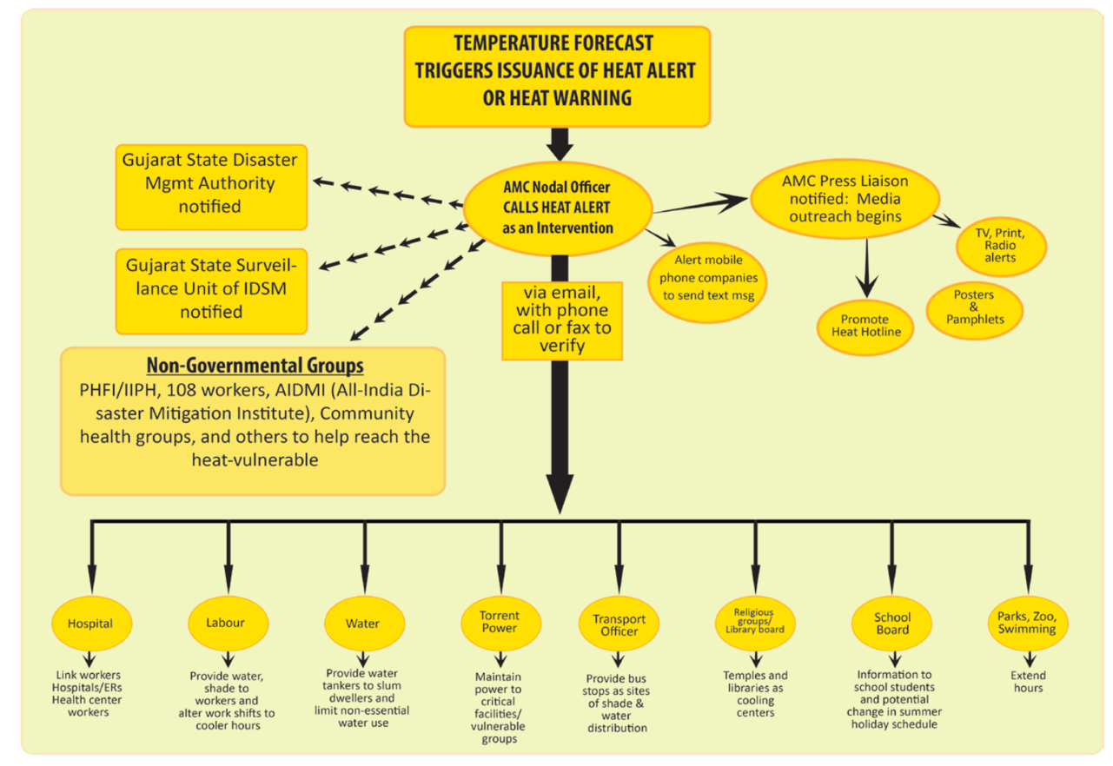

Figure 2. Communications plan for Ahmedabad Heat Action Plan

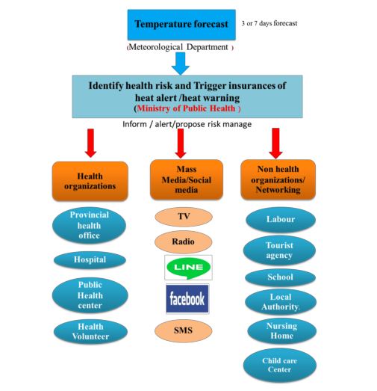

Figure 3. The proposed mechanism for heat health warning system in Thailand.

## Identity of decision makers

Public health protection from disasters, is a responsibility that is not restricted to the health sector. The health sector is positioned to address injuries and illnesses once they happen – but protection of public health is a civic responsibility of many. Be it through individual decisions made by individuals on behalf of their family, to professional roles and responsibilities inside or outside the formal health sector. Awareness of when and where a hazardous event may occur, in a timely manner can allow ‘decision-makers” to make the best call based on the information available to minimize health risks.. These “decision-makers” include, but is not exclusive to:

* National governments
* Local and state government, including social care and school authorities, responsible for vulnerable populations such as children and elderly.
* Employers and private sector
* Social and advocacy groups
* Community groups
* First responders
* Public utility managers (Water, Sanitation, Electricity, Roads, etc)
* Health system managers, ambulatory care services, private and public health care providers
* Individuals and families

## Timeline of key decisions and processes

Taking the example of an extreme temperature event, the WHO recommends an approach with five time frames, which cover long-term preparation as well as responses after the disaster6 :

* (Long –term) Longer-term development and planning
* (Pre-hazard season) Timely preparations before summer (pre-summer)
* (During heightened hazard season) Prevention during the summer
* (Event management) Specific responses to periods of heat/heat waves
* (Post event) Monitoring and evaluation

These timelines are depicted in Figure 4, addressing heat wave preparation:

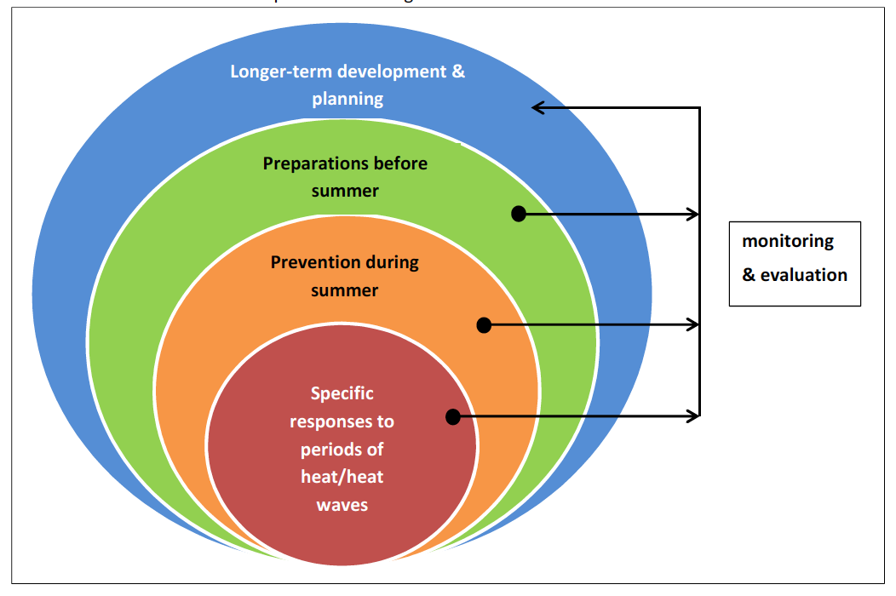

Figure 4. Schematic representation of time frames set out by WHO for implementing the core elements of a heat action plan.3

# Key metrics to track health impacts of and vulnerability to disasters

The health impacts of the five focus hazards are measurable in different ways. Disaster-related metrics provide a key quantification of the effect of disasters on mortality, however morbidities and other impacts are often more far reaching and better measures of a hazard impact on public health. Several global monitoring processes have been created with relevant indicators that may be able to support Hi-Weather research (Table 2):2,7,8

Table 2. Indicators from monitoring processes relevant to disasters.

|  |  |  |
| --- | --- | --- |
| **Monitoring process** | **Disaster(s) relevant** | **Indicator of Impact** |
| Lancet Countdown | 5 (heat) | 1.2 Health effects of heatwaves |
| 1,2,3,4,5 | Climate-resilient health infrastructure |
| Sendai Framework for Disaster Risk Reduction | 1,2,3,4,5 | A-1: Number of deaths and missing due to hazardous events per 100,000 |
| 1,2,3,4,5 | A-2 Number of deaths due to hazardous events |
| 1,2,3,4,5 | A-3 Number of missing due to hazard events |
| 1,2,3,4,5 | B-1 Number of affected people per 100,000 |
| 1,2,3,4,5 | B-2 Number of injured or ill people due to hazardous events |
| 1,2,3,4,5 | B-3 Number of people who left their places of residence due to hazardous events |
| 1,2,3,4,5 | B-3a Number of evacuated people due to hazardous events |
| 1,2,3,4,5 | B-3b Number of relocated people due to hazardous events |
| 1,2,3,4,5 | B-4 Number of people whose houses were damaged due to hazardous events |
| 1,2,3,4,5 | B-5 Number of people whose houses were destroyed due to hazardous events |
| 1,2,3,4,5 | B-6 Number of people who received food relief due to hazardous events. |
| Sustainable Development Goals | 1,2,3,4,5 | 1.5.1 Number of deaths, missing persons and persons affected by disaster per 100,000 people |
| WHO Climate and Health Country Profiles | 5 (heat) | Heat-related mortality |
| 1 (flooding) | Exposure to flooding due to sea level rise |

# Outlines of HIWeather focus areas

## 1. Urban Flooding

### Overview

Urban floods can arise as a result of heavy rainfall caused by thunderstorms cyclones (manifested as flash floods), from river or reservoir overflow, or coastal inundation from tidal surges. Regardless of the both rapid rise and slow rise floods can have a significant impact on public health in urban areas, where populations and economies are most concentrated.9

Between 1995 and 2015, 3,062 flood events were recorded10. Floods were responsible for the majority (56%) of natural disasters; affecting 2.3 billion people worldwide10. In the first half of 2017, floods were reported as 44% (66) of 149 disasters worldwide, with 52% (1,644) of the 3,162 deaths during the period. 11

While the adverse health effects of flooding include many direct impacts on human health at the time of exposure to a flood event, the pathways of how health impacts occur can be complicated and indirect and the onset of health impacts triggered by a flood event may see important time-lags

### **1.1 Health Risks of Urban Flooding**

#### Immediate onset health concerns of urban floodsrequiring prevention and emergency management

**Disruption to essential health care.** In addition to facilities needing specialized emergency management protocols and services related to the flood event – it is critical for routine health care provision to continue even during times of emergency with little interruption, making available uninterrupted obstetric care services, NCD treatment, mental health management, pharmaceutical and surgical services, etc. This often involves networked patient management across a health care system – referring and transferring patients to appropriate care services. Treatment for serious illnesses, such as cancer, can be disrupted by flooding, due to transport infrastructure being knocked out for prolonged periods of time.12 Lack of availability of routine prescription medicines due to flooding may also impact health.13 Health care practitioners may also become overwhelmed by the increased demand for services.9

Power generation facilities, such as in Fukushima during the Japanese tsunami event of 2011, can also be taken suddenly offline, with large environmental and power supply deficits. 14

**Protection of high-risk and in-care populations**

add sentence on those already suffering mental illness, dependent on life-sustaining care (e.g. dialysis) already in hospital or care facilities.

**Drowning, physical trauma, and poisoning.** Rapid rise floods can cause sudden changes to the environment, increasing the risk of drowning and injuries.15 Slow rise floods can also be deadly when there is a lack of preparedness.9 Injuries may include snake or other bites, and electrocution due to power lines. add statement on exposure to toxic chemicals. populations such as women, children, and elderly, disabled unable to swim.

**Electrocution.** For urban authorities, which do not plan for the electricity grid to be shut off before a flood, there can be catastrophic consequences. In the 2011 flood in Thailand, 128 of 919 death resulted from electrocution, with a relative risk of 4.1 of electrocution comparing those in urban areas to those outside.16 96% of deaths from electrocution resulted from circuit breakers in houses not being shut off.16

**Facilitating water-borne and rodent-borne disease transmission.** Diseases can be spread from contaminated surface water by the onset of flooding.17 Flooding of sanitation facilities, disruption to safe drinking water sources, poor hygiene, contact with contaminated surface waters, displacement and contact with other vectors such as rodents. Increased instances of cholera18, diarrheal diseases18, hepatitis A and E18, leptospirosis18, melioidosis19, respiratory infections20, and typhoid18 have been observed after floods in urban areas.

#### Delayed Health Impacts triggered by flood events

**Fungus and Mould.** When flood waters recede dangerous levels of mould grow, particularly in tropical climates and lead to increased asthma, and respiratory complications. Mould can render housing unsafe and uninhabitable within a matter of days.

**Vector-borne Diseases. Malaria, Dengue.** Epidemics in the wake of flooding in tropical regions can occur due to clogging of storm water drains, causing stagnant water to allow genesis of vectors of malaria.20,21

**Malnutrition.** Damage to infrastructure caused by flood, and disruption to food systems can cause appropriate food to be unavailable for prolonged periods, due to spoilage, in availability, loss of economic of physical access to safe and nutritious food, with the poor, children and the elderly being particularly vulnerable.22

**Psychological distress.** The mental health effects of a flood can last long after the flood itself, with reports of increased prevalence of psychological morbidity (including depression, anxiety, PTSD) in residents up to 1 year after floods, particularly if residents are displaced at short notice.23,24

#### Some risk factors associated with urban flooding

While health impacts of urban flooding could affect anyone in an afflicted population, the following demographics are highlighted as possessing a higher risk of mortality or morbidity during a disaster:25

Children.

Pregnant women.

The elderly.

People with physical, sensory and cognitive impairments.

People with chronic illnesses.

Those receiving care at home (e.g. home oxygen, dialysis).

People who are homeless.

People with language and cultural-based vulnerabilities.

Tourists.

### **1.2 How forecasting can improve health risk management in urban floods**

An overview of how the health sector generally benefits from urban flood forecasts, in the context of how:

* What the structure of urban flood action plans generally are
* What decision makers can do with, say, 3 days, 5 days, 7 days, 2 weeks
* The importance of extending the forecast horizon and skill in space and time
* The ‘so what?’

Key decisions are related to when to:

Notify the public

Move assets

evacuate populations and facilities

Trigger contingency plans to maintain health service delivery and protect infrastructure

Establish heightened risk monitoring

Establish emergency operations

Trigger actions to ensure safe food and water provision

Principle questions that need answering

when, where, and how dangerous the flood waters will be

what areas will be safe

how long it will it last, and description of the dynamics of the flood

#### Role of forecasting technology in FAPs

In the event of an urban flood, monitoring and forecasting are essential and invaluable components of saving lives and livelihoods. However, technology alone is not enough, as ‘introducing new hardware with an insufficient *software* component to help the community assess its value themselves, can lead to surprising, counterproductive and even disastrous results’26

An unfortunate example of such competent technology failing to translate into saving lives is when Cyclone Nargis hit Myanmar in May 2008. Although the Indian Meteorological Department identified the cyclone four days before landfall, the ‘last-mile’ of communication to isolated local communities in the low-lying coastal regions via traditional media (including TV, newspapers and radio) was ineffective. It was also found that there were either inadequate or non-existent evacuation plans in these areas, which compounded to making Cyclone Nargis the worst natural disaster in Myanmar’s recorded history. [ref]

As such, it is important that meteorological technologists understand that such hardware fits into the existing local preparedness plans, and the operational decision cycles of those who play important roles in public health protection, such as drinking water facilities managers, pharmacists, ambulatory services, first responders. A Flood Action Plan (FAP) is a comprehensive, clear, and effective plan involving stakeholders and decision makers from several different sectors, including health and meteorology. A FAP’s goal is to save as many lives and livelihoods as possible given the onset of a flood event.

#### Nature of interventions possible through forecasting

Taking example from “The National Flood Emergency Framework for England” three kinds of interventions should be implemented to prevent the health effects of flooding:25

**Primary Prevention.** These measures are planned far in advance and can be structural (e.g. engineering) or non-structural (policy and organisation). E.g. emergency plans, land use management, tree planting, control of water sources and flow, flood defences and barriers, design and architectural strategies and flood insurance.

**Secondary Prevention.** These measures can be taken either just before or during a flood to mitigate the health effects of the flood. E.g. identification of vulnerable or high-risk populations before floods occur (accounting for difficulties in communication and mobility and the needs of people with chronic diseases), early warning systems, evacuation plans including communication and information strategies, and planned refuge areas.

**Tertiary Prevention.** These measures can be taken during and after a flood to minimise health impacts. E.g. moving belongings to safe areas, ensuring the provision of clean drinking water, surveillance and monitoring of health impacts, treating ill people, and recovery and rehabilitation of flooded houses.

HIWeather’s primary contribution for improved health outcomes will take place in the **secondary and tertiary prevention** areas.

#### Advantages for decision makers with accurate and precise forecasting of urban floods

From the moment a trustworthy alert is issued by a meteorological authority of heavy rainfall, cyclone activity or other meteorological events that can lead to flooding, decision makers have limited time to prepare. A good exercise is to understand what can be done with a set period of advanced notice of an urban flood. The following section details health strategies for floods during timescales which are relevant to HIWeather’s goals.

### Examples of Key steps often taken by Health Authorities to reduce health risks in preparation for flood events

#### Weather prediction (in core interest of HIWeather and WWRP)

Short-term actions (2 minutes to 2 weeks) i.e. nowcasting, short-term forecasting:

**Evacuation of low lying communities and health facilities.** Up to 3 days may be required for an effective evacuation of a densely-populated urban area. Safe zones should be pre-identified and can also benefit from hazard mapping.

**Providing alternative water sources. Health facilities, social care institutions, and** vulnerable communities may be isolated for days. As such, they will need to ensure they have drinking supplies for this requisite time. 15 litres per person, per day is a recommended amount, while 7 litres per person is classed as a minimum.27 This can be alleviated by independent emergency water tanks and bladders, or supplying mobile purification units connected to the nearest untreated source27 Health facilities require sufficient clean water to maintain health services throughout an emergency.

**Provision of emergency food supplies.** Three days-worth of food to build up [ref= https://www.ready.gov/floods]

**SOPs for emergency medical transport services during floods.** Ambulatory care may be required before a flood event to support evacuation efforts, including evacuation of hospitals or care facilities, as well as throughout a flood event. Up-to-date information is required by the ambulatory services of safe transport routes that can be used for road vehicles, or where boats or airlifting will be required.

**Emergency shelter preparation and management for displaced communities.** Communities displaced may have to reside in temporary shelters. These need to be pre-identified by authorities and validated to remain safe and functional during the expected magnitude and duration of a flood event. Like food and medical supplies, this may require days of advance preparation and knowledge of safe locations from flood.

**Vector, rodent, carcass, and waste management**

Plans will need to be made for how to manage sources of disease during flood events – which can result from displacement of rodents into residential and medical facilities; the collection and removal of dead animals; and vector control measures to be immediately activated post-flood to control and reduce breeding sites.

**Intoxications and chemical poisonings**

Urban flooding heighten risks related to spillage of fuels and industrial chemicals into flood waters that populations can be exposed to. Identifying facilities and transport systems where hazardous materials are located, and monitoring their integrity to contain these toxins is necessary before, during, and after events. Site inspections following a flood event should certify damages and risks.

Mid-term actions (months) i.e. S2S forecasting:

**Planned emergency management protocols**

**Drilling staff and citizens for urban flood scenarios.** Finding and training reliable staff for a flood scenario requires significant resources. In addition, holding discussions with vulnerable communities about action plans for floods is important to maximise the effectiveness of contingencies.27

#### Climate prediction (outside core interest of HIWeather but of interest to WCRP)

Long-term actions (years) i.e. long-term forecasts and projections:

**Adaptation of buildings and urban infrastructure in vulnerable flood plains.** A long-term preparedness action requires a detailed knowledge of potential flood plains and river overflows. Long-term adaptive action is important in both industrialised and developing nations to safeguard health of vulnerable communities.

**Flood barriers.** Building and planning using high-resolution modelling must be enacted long before a flood. Appropriate flood barriers require building to defend against a flood with a return period chosen after flood modelling.28

**Protection of drinking water sources.** Long-term decisions in urban areas include slow sand filters, which are also appropriate for large cities like London or Amsterdam, and routing permanent water supplies to avoid potential contamination.27 In developing countries, wells may still be the primary source of water, even in urban areas. Raising the head wall of a dug well, and providing a cover and outward-sloping concrete apron around it is one such way of providing additional security to the supply.27

### 1.4 **Public Health Needs for improved real-time monitoring, forecasting and alert capabilities of urban flooding**

Key framework in HIWeather to follow

### Actionable opportunities for weather forecasts to improve health risk management

* added lead-time in forecastsbetter spatial temporal precision
* clearer articulation of probability and uncertainty
* visualizations and mapping of spatial and temporal hazard extent
* wider set of variables and information (see below)
* targeted dissemination to pre-identified decision makers/users

**Key Information and Variables of interest**

* Timing and magnitude of rainfall
* Flood depth
* flood extent
* drainage times
* flood water flow direction –important indication of whether flood water is contaminated
* temperature (important for vectors and mold growth)
* secondary hazards that could be experienced – eg. winds

**Clear messaging of probability, lead times and spatial scales.** Improving precision and ‘believability’ of flood forecasts can and must be improved upon by having clearer messaging on the predictability and processes of weather systems. The trustworthiness of flood forecasts can increase the changes of appropriate action and response by a vulnerable population.29,30 Such ways to improve trustworthiness are diffuse, but include clearer explanation of uncertainty in forecasts, validation of hazards, among other aspects.

**High resolution hazard-exposure mapping** As flood hazard forecasts become more reliable at a higher resolution and longer timescales, hazard-exposure maps (similar to <https://coast.noaa.gov/floodexposure/#/splash)> with detailed overlay of vulnerable groups in flooding (e.g. the elderly, the poor)31 would help to provide targeted aid. This may rely on forecasts of flooding areas being made on the neighbourhood level (~1km resolution for overlay with gridded population datasets like <http://ec.europa.eu/eurostat/data/database)>.

**Vector-borne disease.** Advanced techniques are available for infectious disease mapping with the onset of precipitation, with a one month preparation lead time to adequately prepare medical treatment.32 Working with epidemiologists and infectious disease modellers more closely to understand their needs and wishes would greatly improve their ability to inform medical and emergency services.

**‘Warn on forecast’.** If the forecast skill is significantly improved in a case such as Hurricane Sandy to advance to further days in advance, essential preparations, especially for those less able to move from place-to-place, would be easier and less disruptive. This would require a consistent long-term forecast ensemble, as one of the main reasons Hurricane Sandy was so devastating was due to the conflicting information from competing model forecasts. [ref] This would be especially true for trapped members of the populations, for example those who are stuck in a house to ensure that they have an appropriate amount of food and/or remote medical treatment.

**Improved downscaling of flood forecasts to improve early warning systems.** A study experiment set in Japan demonstrated the benefits improving resolution of flood forecasts for early warning systems.33 This demonstrated that a dramatic improvement in flood forecast downscaling could have significant returns in the preparedness of a population from flood early warning systems.

**Tolerance levels of buildings and drainage systems.** Overflowing sewers and storm drains can lead to flooding and collections of stagnant water, which will both have significant health impacts.9 Under climate change and increasing urbanization, the maximum flows resulting from floods can and should influence design capacity for tolerance of urban storm water. Designing the appropriate drainage system in urbanized areas will depend upon hydro-meteorological characteristics.34 Predictability of long-term maximum estimated flows is therefore an important input of future urban design.

**Preparedness for after the flood** Hurricane Sandy failures in the post-hurricane flood show that more understanding is required by authorities into how the flood will affect infrastructure in the weeks after the flood itself. Improving modelling of water flows after the flood will result in better infrastructure planning, potentially saving many more lives, and certainly avoiding prolonged distress by a population of displacement without knowledge of return.

### **1.5 Potential pilot projects where improved forecasting could be matched with health risk management needs**

Project based on JK’s capabilities comments

**Afghan flood warning**: https://public.wmo.int/en/media/news/afghanistan-meteorological-department-issues-first-flood-early-warning

**Working with food and medicine supply infrastructure in a developing country with early warning system to map pathways to vulnerable communities** Vulnerable members of Pakistan’s population suffered malnutrition from the devastating floods of 2011.22 Working with authorities there, high resolution flood mapping with adequate lead times could aid planning for stockpiling of food.

**Project to create high resolution disease mapping simulations based on prediction of flood.** In early January 2015, devastating rains hit Malawi, resulting in massive floods across the country. This affected an estimated 638,000 people. There were 79 deaths associated with the floods. An outbreak of cholera resulted in 693 cases and 11 deaths. Advanced techniques are available for infectious disease mapping with the onset of precipitation, with a one month preparation lead time to adequately prepare medical treatment.32

**Long-term hospital infrastructure planning using high resolution flood modelling.** During the 2010 flood emergency in Pakistan, more than 500 hospitals and clinics were damaged or destroyed. High resolution extreme flood modelling could aid the planning of new flood-resistant hospitals and clinics, and help shore up existing treatment centres to enable them to continue to run.

**Education and workshops of key disaster relief stakeholders into understanding how forecasting of floods can be reported.** Often a key reason that appropriate action is not taken by a vulnerable population is that there is not sufficient belief that the flood warning will result in a flood. This is true even in industrialised countries like the USA. A key goal could be to work with practitioners who deploy resources in flood warnings to better understand what kind of information they need.

## 2. Wildfire

### Overview

Uncontrolled spread of wildfire can originate from bush, vegetation, forest, heath and grass. Wildfires predominantly occur in countries with warmer climates, they have been known to occur from uncontrolled burning of vegetation in temperature climates such as in the UK.35 Many health impacts result from the inhalation of burnt organic material, but other direct effects are evident.

### Health impacts

#### Immediate onset which can be informed by Public Weather Services

**Burns.** Direct flame and thermal burns can result from a wildfire. The great increase in burns victims in a short time puts significant pressure on health care burns units, which can overwhelming these specialist centres.35

**Carbon monoxide poisoning.** This is mainly a risk to those who are in the immediate vicinity of the fire, such as firefighters. It can cause hypoxic injury, nervous system damage, and death.

**Eye irritation.** Those living close to the wildfires can experience eye irritation, as well as reduced general visibility due to ambient smoke, which can make vehicular accidents more likely.36 Corneal abrasions can also result from the eyes’ exposure to wildfire smoke.37

**Heat-induced illness.** Working in hot and humid conditions can cause many health issues (see ‘Urban Heat Waves and Pollution’). Firefighters can be particularly vulnerable when attempting to deal with the controlling the extent of the fires.

**Particulate matter inhalation.** Burning of organic material can produce several varieties of particulate matter. PM10 (particles under 10µm in diameter) can pass through the upper respiratory tract and are deposited in airways.35 PM2.5 (particles under 2.5 µm in diameter) can penetrate even deeper into the lungs and deposited where gaseous exchange takes place.35 Short-term exposure leads to increases in hospital admissions for respiratory conditions.38 Exposure to particulate matter will cause long-term health problems, and is a known risk factor for cardiopulmonary and lung cancer mortality.39,40

**Respiratory complications.** Breathing in wildfire smoke will exacerbate breathing problems for both children and adults. [ref]

#### Impacts with longer-term onset related to wildfire events

**Psychological distress.** Wildfires can cause the complete destruction of homes and livelihoods. This in turn can lead to depression, anxiety, and PTSD.41

**Water and land contamination.** Large concentrations heavy metals (such as arsenic, cadmium, copper, and lead) have been found deposited in soil from ash debris after a wildfire, which can cause various long-term health effects.42

### Key processes made in preparedness and action plans

#### Climate prediction (outside core interest of HIWeather but of interest to WCRP)

Long-term actions (years) i.e. long-term forecasts and projections:

#### Weather prediction (in core interest of HIWeather and WWRP)

Mid-term actions (months) i.e. S2S forecasting:

### Key gaps in real-time monitoring, forecasting and alert capabilities

### Key opportunities to develop or improve health relevant deliverables

### Potential projects with improved forecasting

Example of Manitoba, Canada.

## 3. Localised Extreme Wind

### Overview

Localised extreme wind manifests in different forms; cyclones (including tropical sub-tropical, extra-tropical storms and polar lows), local windstorms (tornadoes), and downslope windstorms.43

Goldman et al. defines the following categories of wind43:

* **Wind**: motion in the air, described by the average motion over 10 minutes, in metres per second, miles per hour, kilometres per hour, knots (kn: nautical miles per hour) or Beaufort Force. Gale force is a wind speed of more than 34 kn (63 km/h). Storm force is a wind speed of more than 56 kn (103 km/h).
* **Storm**: a disturbed state of the atmosphere of sufficient intensity to present a hazard always involves wind, but may also involve other weather phenomena.
* **Windstorm**: a storm in which the primary hazard comes from the wind speed. Three main categories may be identified: cyclones (including tropical and extra-tropical storms and polar lows), local windstorms (such as tornadoes) and downslope windstorms.

Health impacts

*Content from this section was largely taken from Goldman et al.*43

#### Immediate onset which can be informed by Public Weather Services

**Buildings.** Living in mobile homes is a considerable risk factor for death or severe injury due to movement or overturning of the structure. The building could also collapse.

**Falling trees.** Trees are a major source of danger during localised extreme wind. They are implicated in directly causing deaths by head injury, asphyxiation, or immediately by physical impact.

**Flying debris.** Deaths and morbidity occur due to debris flying at speed causing penetrating or blunt trauma.

**Pre-impact health effects.** Preparation for extreme wind can include installing plywood and metal shutters to secure buildings and reduce the risk of injury from projectiles. Blunt trauma, falls, muscle strains lacerations and stress-induced cardiac incidents were reported to occur during preparation.

Elderly were also vulnerable given that they were often evacuated or moved to shelters in anticipation of the extreme wind event.

**Road accidents.** Edwards states ‘Weather influences the frequency of road accidents by affecting not only the volume of traffic, and therefore the number of road users exposed to risk, but also the risk per unit travel’. High-sided vehicles are at risk during strong cross-winds. Smaller vehicles are also at risk of being blown off-course when exposed to gusts.

#### Impacts with longer-term onset related to extreme wind events

**Carbon monoxide poisoning.** An increase in carbon monoxide (CO) poisoning has been seen following power outages caused by storms. Charcoal briquettes and gasoline-powered electrical generators are principal sources of CO, as well as portable generators being placed in poorly-ventilated spaces. Extreme wind in cold winter months increases the likelihood of portable generators being required for heating.

**Fires/Burns.** Candles are often used as alternative sources of light during power outages caused by extreme wind. This increases the risk of burns and death due to house fires.

**Infections.** Higher rates of infections can result from a lack of electricity and water in the aftermath of an extreme wind event. Gram negative bacilli has been found to occur in victims of infections, due to mud being driven by rain into wounds.

**Insect bites.** Downed trees containing insect nests is thought to cause insects to travel and cause insect bites. 21% of patients during Hurricane Hugo were found to have suffered insect bites.

**Psychological distress.** Damage to structures in homes, the need to relocate temporarily or permanently and homes needing extensive repairs have been risk factors associated with increase in mental health problems, affecting both children and adults alike. Notable increases of Post-Traumatic Stress Disorder were evident in participants of a survey after the impact of Hurricane Andrew. [ref]

**Sea spray.** During windier conditions, higher aerosol loadings could have potential health impacts. During algae blooms, respiratory irritation can be experienced by people living near the shore and winds blow the toxic aerosol onshore.

### Key processes made in preparedness and action plans

#### Climate prediction (outside core interest of HIWeather but of interest to WCRP)

Long-term actions (years) i.e. long-term forecasts and projections:

#### Weather prediction (in core interest of HIWeather and WWRP)

Mid-term actions (months) i.e. S2S forecasting:

### Key gaps in real-time monitoring, forecasting and alert capabilities

### Key opportunities to develop or improve health relevant deliverables

### Potential projects with improved forecasting

## 4. Disruptive Winter Weather

### Overview

During winter, disruption to transport, communications and energy can occur due to snow, ice, fog, and avalanches. It is a major source of social and economic disruption in mid- and high-latitude regions.

Health impacts

#### Immediate onset which can be informed by Public Weather Services

**Burial in snow.** During avalanches, victims are trapped under a large mass of snow and other material, including soil. This can quickly lead to suffocation and crushing. [ref]

**Frost bite.** During extreme cold, ice crystals can form inside body cells, killing them in the process. This can lead to loss of fingers, toes, and limbs in the worst cases.[ref]

**Hypothermia.** A potentially deadly drop in body temperature (below 35.5C). Arises due to prolonged exposure to cold temperatures. This results in the heart failure, decreased nervous system activity, cold diuresis, and non-cariogenic pulmonary edema. [ref]

**Ischaemic heart disease (IHD) and cerebrovascular disease (CVD).** These deaths ‘result from thrombosis due to haemoconcentration in the cold, and from other consequences of cardiovascular reflexes that are briefly induced by low temperatures’.44

**Respiratory disease (RD).**  Generally attributed to cross-infection from indoor crowding. This is exacerbated by the fact that low temperatures assist the survival of bacteria, as well as decreasing the human body’s ability to fight infections.44

**Slipping on snow and ice.** Snow and ice are far more slippery than standard paving and dry ground. This can potentially be very dangerous for those who are vulnerable and alone, especially the young and elderly.45

**Traffic accidents.** Roads can become significantly more hazardous to drive on during disruptive winter weather, as the surfaces become slippery due to ice or slush. Driver awareness during disruptive winter weather is an issue if drivers do not slow down.46

#### Impacts with longer-term onset related to disruptive winter weather events

**Malnutrition.** Disruption to transport and blocking of routes outside of current accommodation can cause individuals to lose access to food and water. [ref] Weight loss can also result as the human body requires more fuel during cold weather to maintain its temperature.

**Psychological distress.** Isolation due to disruption of transport networks can cause distress, due to

**Trench foot.** Occurs when the feet are wet for long periods of time at low temperatures. Can be particularly dangerous for homeless population.

### Key processes made in preparedness and action plans

#### Climate prediction (outside core interest of HIWeather but of interest to WCRP)

Long-term actions (years) i.e. long-term forecasts and projections:

#### Weather prediction (in core interest of HIWeather and WWRP)

Mid-term actions (months) i.e. S2S forecasting:

### Key gaps in real-time monitoring, forecasting and alert capabilities

### Key opportunities to develop or improve health relevant deliverables

### Potential projects with improved forecasting

**Polar Prediction Project.**

## 5. Urban Heat Waves and Air Pollution

### Overview

A heat wave, or extreme hot weather that lasts for several days, has no standard definition.47 However they are reasonably defined, they have a significant impact on society and are associated with a rise in morbidity and mortality.48 The impact of heat waves on human health can be catastrophic, as seen in the tens of thousands of excess deaths recorded in Europe during the summer of 2003,49 the Russian Federation in 2010, and in India in 2010.50 In industrialised countries, heat waves are responsible for deaths than other disasters, with 76% of weather-related disasters due to extreme temperatures between 1995-2015.10 Exposure to dangerous heat waves is forecast to increase under climate change over the current century.51

Those living in urban areas may also experience an amplified heat wave, as the urban heat island phenomenon can increase temperatures significantly compared with the surrounding non-urban area.52

Exposure to UV-rays can be increased during extreme heat.

Air pollution is characterized by a contamination of the indoor or outdoor (ambient) environment by any agent that modifies natural characteristics of the atmosphere. This definition includes aerosols and particulate matter, divided broadly into PM10 and PM2.5. Air pollution is thought to act as an aggravating factor on the health effects of heat waves.53,54 As such, it is important to consider air quality levels when considering the impact of a heat wave on a vulnerable population.

Ozone concentration is also thought to be an adverse modifier on mortality during extreme heat.55

### Health impacts

#### Immediate onset which can be informed by Public Weather Services

**Cerebrovascular accidents.** A stroke is caused by coagulation of blood in the brain, and studies have suggested that the blood of heat stressed individuals coagulates more readily..56

**Harvesting.** When already terminally ill members of a population are exposed to extreme heat, their deaths can be brought forward in time by a few weeks.57

**Heat edema.** Manifests itself as soft tissue swelling in those who are less acclimatised to heat being experienced.58 Cramps are more likely when exercising in hot and humid environments, but especially during exercise.59

**Heat exhaustion.** Common symptoms include headache, dizziness, goose flesh, nausea, vomiting, diarrhoea, irritability, and loss of coordination.59

**Heat rash.** Also known as ‘prickly heat’ or ‘milaria rubra’, heat rash results from sweating which saturates the skin surface, clogging the sweat ducts.58

**Heat stroke.** Clinically defined as when the body’s core temperature is at least 40.6C.60 A life-threatening condition, with a severe elevation of body temperature with central nervous system dysfunction that often includes combativeness, delirium, seizures, and coma.61

**Heat syncope.** Fainting from heat due to elevated body temperature.Syncope can indicate that someone is undergoing heat stroke.59

**Severe dehydration.** Profuse sweating can occur during a heat wave episode. This can lead to dehydration, which depletes electrolytes and causes sodium losses.59

#### Impacts with longer-term onset related to heat wave and air pollution events

### How forecasting informs heat wave and air pollution health action plans

### Key processes made in preparedness and action plans

#### Climate prediction (outside core interest of HIWeather but of interest to WCRP)

Long-term actions (years) i.e. long-term forecasts and projections:

#### Weather prediction (in core interest of HIWeather and WWRP)

Mid-term actions (months) i.e. S2S forecasting:

### Key gaps in real-time monitoring, forecasting and alert capabilities

- probabilistic forecasting for heat waves esp in developing countries where deterministic forecasts are often used.

- skill evaluation and recalibration of heat wave forecasts essential for decision making but still not common practice in many developing countries. Particularly important on longer lead times (S2S) that are being developed now and becoming operational in some places eg. India (This would mean that when there is a forecast of 30% chance of heat wave, a heat wave occurs exactly 30% of the time. Otherwise users can’t trust the probabilities given in the forecast)

- soil moisture is known to be a source of predictability for heat waves in several areas of the world. Challenge to realize this predictability gain in forecasts. Models need to assimilate soil moisture obs well in order to capitalize on this predictability. We need skill assessments of heat wave forecasts on weather to S2S timescales, and evaluation of how well models capture the influence of surface water availability on heat wave generation.

### Key opportunities to develop or improve health relevant deliverables

### Potential projects with improved forecasting

- Potential projects serving as focused health outcome-based research for HIWeather.

- understanding spatial variations in heat wave risk (vulnerability, exposure and hazard) within cities to better target intervention

- evaluation of which heat early warning system interventions work and which do not (will be location/population specific to some extent, but are there some that can be generalised?). This piece would improve efficiency of early warning systems.

- adding warning tiers to alert more vulnerable groups earlier than full-scale alert is issued (this came from Kris Ebi’s work). Would need improvements in forecast lead time and skill for this to work, and recalibrate probabilistic forecasts since we’d be looking at earlier lead times. Needs research on heat-health thresholds for vulnerable groups separately from whole population to set the tiers.

# References

1 European Commission. Science for Disaster Risk Management 2017. 2017 http://drmkc.jrc.ec.europa.eu/.

2 UNISDR. Sendai Framework for Disaster Risk Reduction 2015 - 2030. *Third World Conf Disaster Risk Reduction, Sendai, Japan, 14-18 March 2015* 2015; : 1–25.

3 Recommendations for Action Heat: Action Plans to protect human health. *Bundesministerium für Umwelt, Naturschutz, Bau und Reakt* 2017; : 1–32.

4 World Health Organization Country Office for Thailand. Development of framework on heat-health warning system in Thailand. .

5 Hess JJ, Ebi KL. Iterative management of heat early warning systems in a changing climate. Ann. N. Y. Acad. Sci. 2016; : 21–30.

6 Matthies F, Bickler G, Marin N, Hales S. Heat–health action plans. *WHO Eur* 2008; : 45.

7 Watts N, Adger WN, Ayeb-Karlsson S, *et al.* The Lancet Countdown: tracking progress on health and climate change. *Lancet* 2017; **389**: 1151–64.

8 World Health Organization. Climate and Health Country Profiles 2015. 2015.

9 Hajat S, Ebi KL, Kovats RS, Menne B, Edwards S, Haines A. The human health consequences of flooding in Europe: A review. *Extrem Weather Events Public Heal Responses* 2005; : 185–96.

10 UNISDR, CRED. The human cost of weather-related disasters 1995-2015. *UNISDR Publ* 2015; **1**: 30.

11 EMDAT. Cred Crunch. *Earthquake* 2017; : 1–2.

12 Bennet G. Bristol floods 1968. Controlled survey of effects on health of local community disaster. *Br Med J* 1970; **3**: 454–8.

13 Ochi S, Hodgson S, Landeg O, Mayner L, Murray V. Disaster-Driven Evacuation and Medication Loss: a Systematic Literature Review. *PLoS Curr* 2014; : 1–24.

14 Kajitani Y, Chang SE, M.EERI, Tatano H. Economic Impacts of the 2011 Tohoku-Oki Earthquake and Tsunami. *Earthq Spectra* 2013; **29**.

15 French J, Ing R, Von Allmen S, Wood R. Mortality from flash floods: a review of national weather service reports, 1969-81. *Public Health Rep* 1983; **98**: 584–8.

16 Sukhum Piriyapornpipat, P. Siriarayaporn, H. Kanjanasombat, P. Mawiriya SI. Epidemiology of Electrocution Death Identified by Flood-Related Surveillance During the Worst Flood Disaster in Thailand, 2011. *CDC* 2011; : 2011.

17 Miettinen IT, Zacheus O, Bonsdorff C-H von, Vartiainen T. Waterborne epidemics in Finland in 1998-1999. *Water Sci Technol* 2001; **43**: 67–71.

18 Watson JT, Gayer M, Connolly MA. Epidemics after Natural Disasters. *Emerg Infect Dis* 2007; **13**: 1–5.

19 Munckhof WJ, Mayo MJ, Scott I, Currie BJ. Fatal human melioidosis acquired in a subtropical australian city. *Am J Trop Med Hyg* 2001; **65**: 325–8.

20 Baqir M, Sobani ZA, Bhamani A, *et al.* Infectious diseases in the aftermath of monsoon flooding in Pakistan. *Asian Pac J Trop Biomed* 2012; **2**: 76–9.

21 Srivastava A, Nagpal BN, Saxena R, *et al.* Malaria epidemicity of Mewat region, District Gurgaon, Haryana, India: A GIS-based study. *Curr Sci* 2004; **86**: 1297–303.

22 Brabant M. Six months after floods struck, malnutrition hits hard in affected areas of Pakistan. UNICEF. 2011. https://www.unicef.org/emergencies/pakistan_57553.html.

23 Munro A, Kovats RS, Rubin GJ, *et al.* Effect of evacuation and displacement on the association between flooding and mental health outcomes: a cross-sectional analysis of UK survey data. *Lancet Planet Heal* 2017; **1**: e134–41.

24 Waite TD, Chaintarli K, Beck CR, *et al.* The English national cohort study of flooding and health: cross-sectional analysis of mental health outcomes at year one. *BMC Public Health* 2017; **17**: 129.

25 Government of the UK. The National Flood Emergency Framework for England. *Contin Cent* 2014; : 1–2.

26 IFRC. Community early warning systems. Guiding principles. 2012; : 84.

27 Wisner B, Adams J. Chapter 7. Water supply. *Environ Heal Emergencies Disasters a Pract Guid* 2003; : 92–126.

28 Dawson RJ, Hall JW, Bates PD, Nicholls RJ. Quantified Analysis of the Probability of Flooding in the Thames Estuary under Imaginable Worst-case Sea Level Rise Scenarios Quantified Analysis of the Probability of Flooding in the Thames Estuary under Imaginable Worst-case Sea Level Rise Scenarios. *Int J Water Resour Dev* 2007; **21**: 577–91.

29 Morss RE, Mulder KJ, Lazo JK, Demuth JL. How do people perceive, understand, and anticipate responding to flash flood risks and warnings? Results from a public survey in Boulder, Colorado, USA. *J Hydrol* 2016; **541**: 649–64.

30 Lazo JK, Bostrom A, Morss RE, Demuth JL, Lazrus H. Factors Affecting Hurricane Evacuation Intentions. *Risk Anal* 2015; **35**: 1837–57.

31 Rufat S, Tate E, Burton CG, Maroof AS. Social vulnerability to floods: Review of case studies and implications for measurement. *Int J Disaster Risk Reduct* 2015; **14**: 470–86.

32 Pasetto D, Finger F, Rinaldo A, Bertuzzo E. Real-time projections of cholera outbreaks through data assimilation and rainfall forecasting. Adv. Water Resour. 2016; **0**: 1–12.

33 Yu W, Nakakita E, Jung K. Flood Forecast and Early Warning with High-Resolution Ensemble Rainfall from Numerical Weather Prediction Model. *Procedia Eng* 2016; **154**: 498–503.

34 Chen CF, Liu CM. The definition of urban stormwater tolerance threshold and its conceptual estimation: An example from Taiwan. *Nat Hazards* 2014; **73**: 173–90.

35 Finlay SE, Moffat A, Gazzard R, Baker D, Murray V. Health impacts of wildfires. *PLoS Curr* 2012; : 1–23.

36 Hänninen OO, Salonen RO, Koistinen K, Lanki T, Barregard L, Jantunen M. Population exposure to fine particles and estimated excess mortality in Finland from an East European wildfire episode. *J Expo Sci Environ Epidemiol* 2009; **19**: 414–22.

37 Shustermann D, Kaplan JZ, Canabarro C. Immediate Health-Effects of an Urban Wildfire. *West J Med* 1993; **158**: 133–8.

38 Morgan G, Sheppeard V, Khalaj B, *et al.* Effects of bushfire smoke on daily mortality and hospital admissions in Sydney, Australia. *Epidemiology* 2010; **21**: 47–55.

39 Pope III CA, Burnett RT, Thun MJ, Calle EE, Krewski D, Thurston GD. Lung Cancer, Cardiopulmonary Mortality, and Long-term Exposure to Fine Particulate Air Pollution. *J Am Med Assoc* 2002; **287**: 1132–41.

40 Katsouyanni K, Touloumi G, Spix C, *et al.* Short-term effects of ambient sulphur dioxide and particulate matter on mortality in 12 European cities: results from time series data from the APHEA project. Air Pollution and Health: a European Approach. *BMJ* 1997; **314**: 1658–63.

41 American Psychological Association. Recovering From Wildfires. 2011. http://www.apa.org/helpcenter/wildfire.aspx.

42 Wittig V, Williams S, DuTeaux SB. Public Health Impacts of Residential Wildfires: Analysis of Ash and Debris from the 2007 Southern California Fires. *Epidemiology* 2008; **19**: S207.

43 Goldman A, Eggen B, Golding B, Murray V. The health impacts of windstorms: A systematic literature review. *Public Health* 2014; **128**: 3–28.

44 The Eurowinter Group. Cold exposure and winter mortality from ischaemic heart disease, cerebrovascular disease, respiratory disease, and all causes in warm and cold regions of Europe. *Lancet* 1997; **349**: 1341–6.

45 Björnstig U, Björnstig J, Dahlgren A. Slipping on ice and snow - Elderly women and young men are typical victims. *Accid Anal Prev* 1997; **29**: 211–5.

46 Pisano PA, Goodwin LC, Rossetti MA. U.S. highway crashes in adverse road weather conditions. *24th Conf Institutional Inf Process Syst* 2008; : 1–15.

47 Robinson PJ. On the definition of a heat wave. *J Appl Meteorol* 2001; **40**: 762–75.

48 Baccini M, Kosatsky T, Analitis A, *et al.* Impact of heat on mortality in 15 European cities: attributable deaths under different weather scenarios. *J Epidemiol Community Heal* 2011; **65**: 64–70.

49 Fouillet A, Rey G, Laurent F, *et al.* Excess mortality related to the August 2003 heat wave in France. *Int Arch Occup Environ Health* 2006; **80**: 16–24.

50 Azhar GS, Mavalankar D, Nori-Sarma A, *et al.* Heat-related mortality in India: Excess all-cause mortality associated with the 2010 Ahmedabad heat wave. *PLoS One* 2014; **9**. DOI:10.1371/journal.pone.0091831.

51 Jones B, O’Neill BC, McDaniel L, McGinnis S, Mearns LO, Tebaldi C. Future population exposure to US heat extremes. *Nat Clim Chang* 2015; **5**: 652–5.

52 Tan J, Zheng Y, Tang X, *et al.* The urban heat island and its impact on heat waves and human health in Shanghai. *Int J Biometeorol* 2010; **54**: 75–84.

53 Shaposhnikov D, Revich B, Bellander T, *et al.* Mortality related to air pollution with the moscow heat wave and wildfire of 2010. *Epidemiology* 2014; **25**: 359–64.

54 Fischer PH, Brunekreef B, Lebret E. Air pollution related deaths during the 2003 heat wave in the Netherlands. *Atmos Environ* 2004; **38**: 1083–5.

55 Filleul L, Cassadou S, Médina S, *et al.* The relation between temperature, ozone, and mortality in nine French cities during the heat wave of 2003. *Environ Health Perspect* 2006; **114**: 1344–7.

56 Semenza JC, McCullough JE, Flanders WD, McGeehin MA, Lumpkin JR. Excess hospital admissions during the July 1995 heat wave in Chicago. *Am J Prev Med* 1999; **16**: 269–77.

57 Le Tertre A, Lefranc A, Eilstein D, *et al.* Impact of the 2003 heatwave on all-cause mortality in 9 French cities. *Epidemiology* 2006; **17**: 75–9.

58 Howe AS, Boden BP. Heat-related illness in athletes. *Am J Sports Med* 2007; **35**: 1384–95.

59 Beltran GW. Heat-related illness. *Emerg Med Serv Clin Pract Syst Overs Second Ed* 2015; **1**: 358–62.

60 R, Donoghue E, A, Graham M, M, Jentzen J, D, Lifschultz B, Luke JL. Criteria for the diagnosis of heat-related deaths: National Association of Medical Examiners. Position paper. National Association of Medical Examiners Ad Hoc Committee on the Definition of Heat-Related Fatalities. *Am J Forensic Med Pathol* 1997; **18**.

61 Leon LR, Bouchama A. Heat stroke. *Compr Physiol* 2015; **5**: 611–47.